Contents

Lab1 2

Lab2 4

Lab3 7

Lab4 9

Lab5 11

Lab6 13

Lab7 19

Lab8 20

Lab9 21

Lab10 23

Lab11 27

Lab12 30

Lab13 31

# Lab1

1. **Question 1: Comparing Algorithms of following problem.**

Find the largest distance between any two even integers in an integer array.

1. Algorithm 1. Create a new array consisting of even numbers only. Then use nested loops to solve the problem using the newly created array of even numbers only.
2. Algorithm 2. Use a nested loop to solve the problem without creating an extra array.
3. Algorithm 3. Use one loop. Find max and min of even integers. Compute max – min.
4. Algorithm 4. Use Streams to find the max and min. Compute max – min

I executed above 4 algorithms with 4 different size of arrays. Arrays are generated as random and result wrote to the file. Execution time is in milliseconds.

|  |  |  |  |  |
| --- | --- | --- | --- | --- |
| Size of Array | Time of algorithm 1 | Time of algorithm 2 | Time of algorithm 3 | Time of algorithm 4 |
| 10,000 | 83 | 249 | 1 | 17 |
| 20,000 | 252 | 945 | 1 | 17 |
| 30,000 | 552 | 2171 | 2 | 18 |
| 40,000 | 945 | 3839 | 2 | 19 |

Figure 1. Comparison of execution time

As shown in graph above, Algorithm3 and algorithm4 are more efficient than algorithm1 and algorithm2. Because last two algorithm’s execution time is almost constant when we increase size of array. Furthermore, the first two algorithm’s execution times depend on the size of input array which means, in order to reduce execution time, we should use one loop or stream instead of using nested loops.

Also, algorithm1 is using additional list for creating even numbers array which means it will use more memory that other three algorithms.

1. **Question 2: Proof by Induction Let F(n) denote the nth Fibonacci number. Prove $F\left(n\right)>{(\frac{4}{3})}^{n}$ for n > 4.**

**Best Cases:**

n = 5;

$F\left(5\right)>{\left(\frac{4}{3}\right)}^{5}$ => $3>2\frac{26}{243}$

n = 6;

$F\left(6\right)>{\left(\frac{4}{3}\right)}^{6}$ => $5>2\frac{590}{729}$

Hence the results true for n=5 and n=6.

**Induction hypothesis**

Assume result is true for n > 4 and $n≤k$

$F\left(n\right)>{\left(\frac{4}{3}\right)}^{n}$

**Induction step**

We need to prove the result of n = k + 1

$F\left(k+1\right)>{\left(\frac{4}{3}\right)}^{k+1}$

By induction hypothesis

Proof

$F\left(k+1\right)=F\left(k\right)+ F\left(k-1\right)> {\left(\frac{4}{3}\right)}^{k}+{\left(\frac{4}{3}\right)}^{k-1}= {\left(\frac{4}{3}\right)}^{k-1}*\left(\frac{4}{3}+1\right)={\left(\frac{4}{3}\right)}^{k-1}*\left(\frac{7}{3}\right)={\left(\frac{4}{3}\right)}^{k-1}*\left(\frac{7}{3}\right)={\left(\frac{4}{3}\right)}^{k-1}*\left(\frac{21}{9}\right)>{\left(\frac{4}{3}\right)}^{k-1}*\left(\frac{16}{9}\right)={\left(\frac{4}{3}\right)}^{k-1}*{\left(\frac{4}{3}\right)}^{2}= {\left(\frac{4}{3}\right)}^{k-1+2}={\left(\frac{4}{3}\right)}^{k+1}\underset{⇔}{} F\left(k+1\right)>{\left(\frac{4}{3}\right)}^{k+1}\underset{⇒}{k+1 = n}F\left(n\right)>{\left(\frac{4}{3}\right)}^{n}$

# Lab2

1. **Question 1: Comparing Algorithms of following problem.**

Algorithm distance1(A)

Input: An integer array A

Output: Largest distance between two even elements in the array A

distance ← 0

size ← 0

for i ← 0 to A.length–1 do

if A[i] % 2 = 0 then

size ← size + 1

C ← new Array(size)

t ← 0

for i ← 0 to A.length–1 do

if A[i] % 2 = 0 then

C[t] ← A[i]

t ← t + 1

for i ← 0 to C.length–2 do

for j ← i to C.length–1 do

if |A[i]-A[j]| > distance then

distance ← |A[i]-A[j]|

return distance

**Time Complexity: O(n2)**

Algorithm distance2(A)

Input: An integer array A

Output: Largest distance between two even elements in the array A

distance ← 0

for i ← 0 to A.length–2 do

for j ← i to A.length–1 do

if A[i] % 2 = 0 and A[j] % 2 = 0 then

if |A[i]-A[j]| > distance then

distance ← |A[i]-A[j]|

return distance

**Time Complexity O(n2)**

Algorithm distance3(A)

Input: An integer array A

Output: Largest distance between two even elements in the array A

min ← largest

max ← smallest

for i ← 0 to A.length–1 do

if A[i]%2 = 0 then

if A[i] > max then

max ← A[i]

if A[i] < min then

min ← A[i]

return (max-min)

**Time Complexity O(n)**

* 1. **Are they consistent? What did you learn from W1D1 and W1D2?**

As shown below table, we can see that the execution time of Algorithm1 and Algorithm2 were sharply/quickly raised comparing to Algorithm3 when input size increases, because of their time complexity.

First two algorithms’ time complexity is O(n2) which is parabolic while last algorithm’s time complexity is O(n) which is linear.

1. **Question 2. Consider the following functions to determine the relationships that exist among the complexity classes they belong.**

|  |  |
| --- | --- |
| f | Big Ө |
| 10, 1 | Ө(1) |
| log n, ln n, log( log n ) | Ө(log n) |
| n1/k | Ө(n1/k) |
| n1/3 | Ө(n1/3) |
| n1/3 log n | Ө(n1/3 log n) |
| n1/2 | Ө(n1/2) |
| n1/2 log n | Ө(n1/2 log n) |
| n log n, log nn | Ө(n log n) |
| n2 | Ө(n2) |
| n3 | Ө(n3) |
| nk | Ө(nk) |
| 2n | Ө(2n) |
| 3n | Ө(3n) |
| n! | Ө(n!) |
| nn | Ө(nn) |

# Lab3

**Question 1.** **Write an algorithm**

Algorithm beautiful(A, n)

Input: An integer array A with n elements

for i ← 0 to A.length–1 do

print(A[i])

**Question 2. Order them based on their complexity.**

1. 2^n
2. 2^(n + 1)
3. 2^(2n)
4. 2^( 2^n )

**Question 3. Mention one algorithm you know for each of the time complexities listed**.

1. O(1) – Pushing or Popping on Stack
2. O(log n) – Binary Search
3. O(n) – Traversing an array,
4. O(n log n) – Quick Sort,
5. O(n2) – Insertion Sort
6. O(n3) – Traversing 3D array
7. O(2n) – Recursive calculation of Fibonacci numbers

**Question 4. Apply Master Theorem and determine the time complexity of**

1. fib(n) = O(2n)

we can’t use master theorem on Fibonacci because our b = 1/we won’t divide the input/ so to calculate time complexity of Fibonacci sequence we need to solve T(n) = T(n-1) + T(n-2) which means O(2n)

b) binSearch(n) = Ө(log n)

As master formula:

T(1) = d,

T(n) = T($\frac{n}{2}$) + c

So, a = 1, b = 2, k = 0, c = 1

bk = 20 = 1

Hence a = bk => T(n) is in Ө(nk log *n*) = Ө(n0 log*n*) = Ө(log *n*)

**Question 5. Practice Master theorem. It is a very important result in Analysis of algorithms. There are many resources on the internet. Show three different examples covering three possible cases. Show your detailed work.**

1. **SelectionSort**

for j ← 1 to n-1

         smallest ← j  
           for i ← j + 1 to n  
                   if A[ i ] < A[ smallest ]  
                          smallest ← i  
            Exchange A[ j ] ↔ A[ smallest ]

There are two loops so T(N) = (n2)

1. **QuickSort**

/* low --> Starting index, high --> Ending index */

quickSort(arr[], low, high)

{

if (low < high)

{

/* pi is partitioning index, arr[pi] is now

at right place */

pi = partition(arr, low, high);

quickSort(arr, low, pi - 1); // Before pi

quickSort(arr, pi + 1, high); // After pi

}

}

As master formula:

T(1) = d,

T(n) = 2T($\frac{n}{2}$) + n*c

So, a = 2, b = 2, k = 1, c = 1

bk = 21 = 2

Hence a = bk => T(n) is in Ө(nk log *n*) = Ө(n1 log *n*) = Ө(n*log *n*)

1. **If we divide 3 times**

As master formula:

T(1) = d,

T(n) = T($\frac{n}{2}$) + c

So, a = 3, b = 2, k = 0, c = 1

bk = 20 = 1

Hence a > bk => T(n) is in Ө(nlog ba) = Ө(nlog 23) = n1.5

# Lab4

**Question 1. An array S of size 10 is filled with four different letters A, B, C and D. Assume that all four letters are equally likely to appear in the array S. However, there is no guarantee that all four letters are in the array.**

a) What is the average number of array locations to inspect to find a D? Give your answer using a formula or result mentioned in the class note. Please give the Slide number as a reference.

b) Let Z be the random variable such that Z = 1 means the first D in the array is found in the first location. Z = 2 means the first D in the array is found in second location and so on. Compute E(Z). (Note Z = 0 if D is not in the array)

**Answer of a**

There are 4 letters /A, B, C, D/ so our probability equals 1/4.

|  |  |  |
| --- | --- | --- |
| **Array location /X/** | **P(X=D)** | **X*P(D)** |
| 1 | ¼ | ¼ |
| 2 | ¼ | 2/4 |
| 3 | ¼ | ¾ |
| 4 | ¼ | 4/4 |
| 5 | ¼ | 5/4 |
| 6 | ¼ | 6/4 |
| 7 | ¼ | 7/4 |
| 8 | ¼ | 8/4 |
| 9 | ¼ | 9/4 |
| 10 | ¼ | 10/4 |
| Total | | 5.5 |

If we try get main formula from X*P(D) and n = size of array it will become

$$E\left(X\right)=\sum{X*P(X=d)}= \frac{n-1}{2}= \frac{10-1}{2}=5.5$$

Reference: Lecture 3, page number 4, topic Excepted value.

**Answer of b**

For this answer we used **Bernoulli Trials of result one** /lecture 3, page number 13, topic result 1/

The Expected number (average number) of trials for a success = **𝟏/P**

As our formula

$$E\left(X\right)=\sum{X*P(X=z)}=\frac{1}{p}=\frac{1}{\frac{1}{4}}=4$$

**Question 2. An array of size 100 is filled with four different letters A, B, C and D. Assume that all four letters are equally likely to appear in the array S. However, there is no guarantee that all four letters are in the array.**

(a) What is the average number of array locations to inspect to find 10 D’s? Give your answer using a formula or result mentioned in the class note. Please give the Slide number as a reference.

(b) What is the average number of array locations to inspect to find k D’s? Give your answer using a formula or result mentioned in the class note. Please give the Slide number as a reference.

(c) What is the “average time complexity” to find k D’s in an array?

**Answer of a**

For this answer we used Bernoulli Trials of result two /lecture 3, page number 15, topic result 1/

Expected number (average number) of trials for k successes = **𝒌/p**

**K = 10, P= 1/4**

$$E\left(D_{10}\right)=\sum{X*P(X=d)}=\frac{K}{p}=\frac{10}{\frac{1}{4}}=40$$

**Answer of b**

For this answer we used **Bernoulli Trials of result two** /lecture 3, page number 15, topic result 1/

Expected number (average number) of trials for k successes = **𝒌/p**

**K = 10, P= 1/4**

$$E\left(D_{k}\right)=\sum{X*P\left(X=d\right)}=\frac{K}{p}=\frac{K}{\frac{1}{4}}=4K$$

**Answer of C**

We run through the array one time so it’s time complexity is O(n).

**Question 3. Prove: 1 + 1/2 + 1/3 + …+ 1/n = O(log n).**

$$\frac{1}{1}+\frac{1}{2}+ \frac{1}{3}+\frac{1}{4}+\frac{1}{5}+…+ \frac{1}{n}≤ \frac{1}{1}+\frac{1}{2}+\frac{1}{2}+\frac{1}{4}+\frac{1}{4}+\frac{1}{4}+\frac{1}{4}+…= \frac{2^{0}}{2^{0}}+2^{1}*\frac{1}{2^{1}}+2^{2}*\frac{1}{2^{2}}+…+2^{\log_{2}\left(n+1\right)}*\frac{1}{2^{\log_{2}\left(n+1\right)}}= \log_{2}\left(n+1\right)=O(log\left(n+1\right))$$

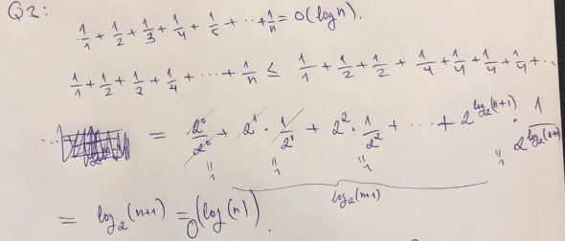

**Question 4. Find the sum: 1/2 + 2/4 + 3/8 + 4/16 + 5/32 + …**

$$S=\frac{1}{2}+\frac{2}{4}+\frac{3}{8}+\frac{4}{16}+\frac{5}{32}+…= ?$$

$$\frac{S}{2}=\frac{1}{2*2}+\frac{2}{4*2}+\frac{3}{8*2}+\frac{4}{16*2}+\frac{5}{32*2}+…=\frac{1}{4}+\frac{2}{8}+\frac{3}{16}+…$$

$$S-\frac{S}{2}=\frac{1}{2}+\frac{1}{4}+\frac{1}{8}+\frac{1}{16}+\frac{1}{32}+…= 1$$

$$S\left(1-\frac{1}{2}\right)=1=>S=\frac{1}{(1-\frac{1}{2})}=2$$

# Lab5

**Question 1. Goal of this question is to understand inversions.**

|  |  |  |  |
| --- | --- | --- | --- |
| Bubble Sort | Iteration | Inversions | # inversions |
| {34,8,64,51,32,21} | 0 | (34,8), (34,32), (34,21), (64,51), (64,32), (64,21), (51,32), (51,21), (32,21) | 9 |
| {8,34,51,32,21,64} | 1 | (34,32), (34,21),(51,32), (51,21), (32,21) | 5 |
| {8,34,32,21,51,64} | 2 | (34,32), (34,21), (32,21) | 3 |
| {8,32,21,34,51,64} | 3 | ((32,21) | 1 |
| {8,21,32,34,51,64} | 4 |  | 0 |
|  |  |  | **18** |
| Selection Sort | Iteration | Inversions | # inversions |
| {34,8,64,51,32,21} | 0 | (34,8), (34,32), (34,21), (64,51), (64,32), (64,21), (51,32), (51,21), (32,21) | 9 |
| {8,34,64,51,32,21} | 1 | (34,32), (34,21), (64,51), (64,32), (64,21), (51,32), (51,21), (32,21) | 8 |
| {8,21,64,51,32,34} | 2 | (64,51), (64,32), (64,34), (51,32), (51,34) | 5 |
| {8,21,32,51,64,34} | 3 | (64,34), (51,34) | 2 |
| {8,21,32,34,64,51} | 4 | (64,51) | 1 |
| {8,21,32,34,51,64} | 5 |  | 0 |
|  |  |  | **25** |
| Insertion Sort | Iteration | Inversions | # inversions |
| {34,8,64,51,32,21} | 0 | (34,8), (34,32), (34,21), (64,51), (64,32), (64,21), (51,32), (51,21), (32,21) | 9 |
| {8,34,64,51,32,21} | 1 | (34,32), (34,21), (64,51), (64,32), (64,21), (51,32), (51,21), (32,21) | 8 |
| {8,34,64,51,32,21} | 2 | (34,32), (34,21), (64,51), (64,32), (64,21), (51,32), (51,21), (32,21) | 8 |
| {8,34,51,64,32,21} | 3 | (34,32), (34,21), (64,32), (64,21), (51,32), (51,21), (32,21) | 7 |
| {8,32,34,51,64,21} | 4 | (34,21),(64,21),(51,21) | 3 |
| {8,21,32,34,51,64} | 5 |  | 0 |
|  |  |  | **35** |

**Question 2. Aim of this question is to understand amortized cost analysis**

**The function c is the “real” cost. Function ĉ is what we are charging our customer. Balance shows how much cash we have. We never want the balance to be negative.**

**c function:** 1 to add. 3k to resize (if k >0. Note: k is the size of the “completely filled array”)

**ĉ function:** 7 to add. (customer is willing to pay for add) 0 to resize (customer do not want to pay for resizing. It is not his/her concern)

|  |  |  |  |  |  |  |
| --- | --- | --- | --- | --- | --- | --- |
| **Item #** | **Operation** | **Cost for us** | **Customer paid** | **Profit** | **Balance** | **Array Size** |
| 1 | Add | We assume we start with 1 slot. We add 1 item at the cost of 1. | 7 | 6 | 6 | 1 |
| 2 | Add | 3 to resize (We have two slots) 1 to add | 7 | 6 | **3**  9 | 2 |
| 3 | Add | 6 to resize (We have 4 slots) 1 to add | 7 | 6 | 3  9 | 4 |
| 4 | Add | 1 to add | 7 | 6 | 15 |  |
| 5 | Add | 12 to resize (We have 8 slots) 1 to add | 7 | 6 | **3**  9 | 8 |
| 6 | Add | 1 to add | 7 | 6 | 15 |  |
| 7 | Add | 1 to add | 7 | 6 | 21 |  |
| 8 | Add | 1 to add | 7 | 6 | 27 |  |
| 9 | Add | 24 to resize (We have 16 slots) 1 to add | 7 | 6 | **3**  9 | 16 |
| 10 | Add | 1 to add | 7 | 6 | 15 |  |
| 11 | Add | 1 to add | 7 | 6 | 21 |  |
| 12 | Add | 1 to add | 7 | 6 | 27 |  |
| 13 | Add | 1 to add | 7 | 6 | 33 |  |
| 14 | Add | 1 to add | 7 | 6 | 39 |  |
| 15 | Add | 1 to add | 7 | 6 | 45 |  |
| 16 | Add | 1 to add | 7 | 6 | 51 |  |
| 17 | Add | 48 to resize (We have 32 slots) 1 to add | 7 | 6 | **3**  9 | 32 |
| 18 | Add | 1 to add | 7 | 6 | 15 |  |

After inspecting 18 rows, we can predict the minimum value of balance is **3.**

# Lab6

**Question 1. Design and Analysis of the algorithms**

1. Consider an array of “Wooden blocks toys”. One of the features of these toys is that they are painted either Blue or Red. Devise an algorithm to keep all the Blue toys together at one end of the array and all Red toys together at the other end of the array. Is your algorithm in place? If not, what is the space complexity? What is the time complexity?

Red ← 0

Blue ← 1

DeviseBlocks(A, left, right)

Inputarray A size of n 0 and 1

Output array of 0 at left, 1 at right

pivot ← A[left]

i ← left

k ← right - 1

while i < j do

while A[i] <= pivot do i←i +1

while A[j] > pivot do j←j-1

swap (A[i], A[j])

i ← i + 1

j ← j – 1

swap(A[i], pivot)

DeviseBlocks(A, 0, i-1)

DeviseBlocks(A, i+1, right)

return A

The above pseudo code will doesn’t require any other array which means in place algorithm. Also the algorithm is quicksort. The time complexity of quicksort is O(nlogn). For our algorithm, it will work in O(nlogk) = O(n log2) = O(n). Space complexity is O(1) for in place algorithm.

1. Solve it for three different colors: Blue, Red and Green. Is your algorithm in place? If not, what is the space complexity? What is the time complexity? Remember we are more concerned about the time complexity

Yes, Our algorithm is works perfect in 3 different colors also it’s in-place. Time complexity is same as quicksort which is O(nlogn). For our algorithm, it will work in O(nlogk) = O(n log3) = O(n). Space complexity is O(1) for in place algorithm.

1. Solve it for four different colors: Blue, Red, Green and Yellow. Is your algorithm in place? If not, what is the space complexity? What is the time complexity? Remember we are more concerned about the time complexity.

Yes, Our algorithm is works perfect in 4 different colors also it’s in-place. Time complexity is same as quicksort which is O(nlogn). For our algorithm, it will work in O(nlogk) = O(n log4) = O(2n) = O(n). Space complexity is O(1) for in place algorithm.

**Question 2. Illustrate Quick sort. Since we do not have a random number generator, please pick a pivot so that they lead to alternating between “Good Self Call” and “Bad Self Call”.**

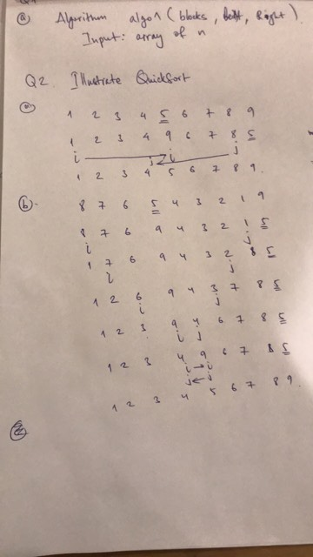

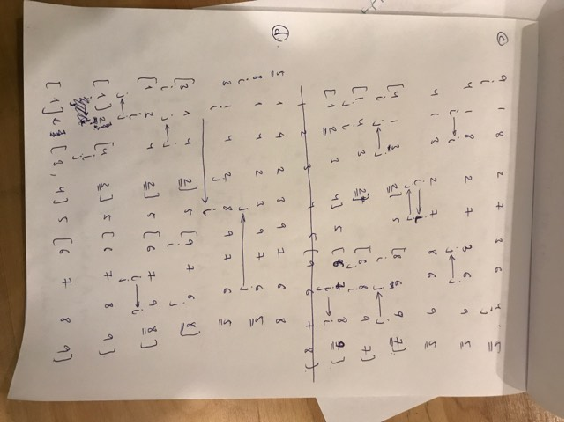

**Question 3. Illustrate quickSelect. Since we do not have a random number generator, please pick a pivot so that they lead to alternating between “Good Self Call” and “Bad Self Call”.**

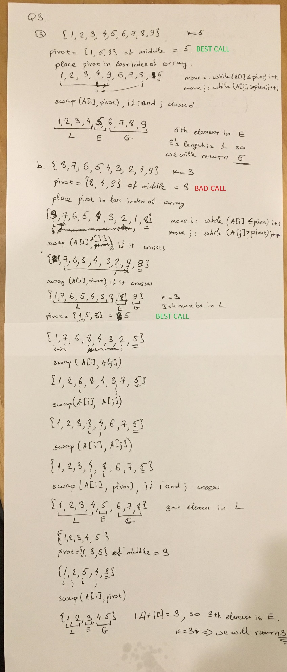

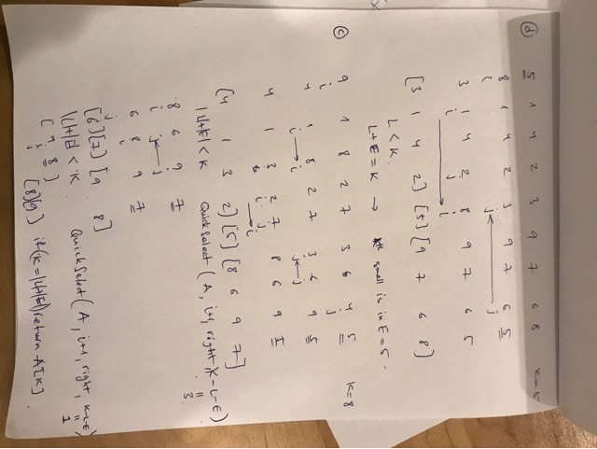

**Question 4. Exploration Let us redefine “Good Self Call” and “Bad Self Call” Good self-call: the sizes of L and G are each less than 2n/3 (normal division) Bad self-call: one of L and G has size greater than or equal to 2n/3.**

**(a). Repeat the calculations shown in Slides 15, 16 and 17. (You need not draw pictures).**

If all self-calls are good, height of tree is m = 1 + log3/2 n. So, the expected number of levels to get m self-calls is still O(logn) Therefore, the cost for processing at each level is n, time complexity is O(n) and the height is O(logn) => We can conclude that average case running time is O(nlogn). This is no change as compared to ¾ way of division.

**(b). Are you able to derive the same results in Slides 16 and 17? If not, why?**

SAME

# Lab7

**Question 1. Practice Radix Sort Repeat what I have done in Slides 24 and 25. Let Radix be 9. Array to be sorted is {179, 721, 639, 549, 292, 427, 335, 435, 62}**

**Key%9**

179%9 = 8, 721%9 = 1, 639%9 = 0, 549%9 = 0, 292%9 = 4, 427%9 = 4, 335%9 = 2, 435%9 = 3, 62%9 = 8

After that array will become

**{639, 549, 721, 335, 435, 292, 427, 179, 62}**

**(Key/9)%9**

(639/9)%9 = 8, (549/9)%9=7, (721/9)%9=8, (335/9)%9=1, (435/9)%9=3, (292/9)%9=5, (427/9)%9=2, (179/9)%9=1, (62/9)%9=6

After that array will become

**{335, 179, 427, 435, 292, 62, 549, 639, 721}**

**(Key/9)/9**

(335/9)/9=4, (179/9)/9=2, (427/9)/9=5, (435/9)/9=5, (292/9)/9=3, (62/9)/9=0, (549/9)/9=6, (639/9)/9 = 7, (721/9)/9=8

After that array will become

**{62, 179, 292, 335, 427, 435, 549, 639, 721}**

**Question 2. Experimenting with lower bound Devise an algorithm to sort 4 elements using exactly 5 comparisons in the worst case. Does this violate the theoretical lower bound? Justify your answer.**

Suppose we have a decision tree T for a sorting algorithm running on input of size n. Then T has n! leaves. So the height of T is at least ┌ log n!┐ so some leaf in T has depth at least ┌ log n!┐. Therefore, in the worst case, at least ┌ log n!┐ comparisons are performed, so running time is Ω(log n!). We determine the complexity class of log n!

As below summary, we got theorem that

Height of the tree: h>=log(n!)

Number of comparisons in the worst case >=log(n!)

We are going to sort 4 elements which means n = 4, ┌ log n!┐ = ┌ log 4!┐ > 5 we need integer that our tree height is integer.

Furthermore, 5 of comparisons is what we needed which means it doesn’t violate the theoretical lower bound.

**Question 3. Exploring new ideas: Forward and backward sorted array (FBS array) Definition An array is said to be FBS array if it satisfies the following three conditions.**

**(1) Elements in the even locations are sorted in the ascending order.**

**(2) Elements in the odd locations are sorted in the descending order.**

**(3) Every element in the even locations are <= every element in the odd locations.**

**Example {7, 20, 10, 19, 10, 17, 14, 15, 15} What is the asymptotic running time of your algorithm? What is the fastest possible asymptotic running time for such an algorithm? Prove your answer.**

**Step 1:** Sort the array FBS by MergeSort as normal. MergeSort Tetha, Big O and Big Omega are same at nlogn.

**Step 2:** Create a new array A as following:

i <- 0,

j<-FBS.length-1

while(I <= j) {

A[i] = FBS[i];

A[i+1] = FBS[j];

i++;

j--;

}

The order of the algorithm is O(n) since it has a for statement. then, the total order will be O(nlogn)+O(n)=O(nlogn)

# Lab8

**To do:**

1. **Implement a recursive algorithm to count the number of nodes.**

public int count() {

return this.recurseiveCount(head,0);

}

private int recursiveCount(Node node, int count) {

if(node==null) {

return count;

}

return this.recursiveCount(node, count + 1);

}

**(b) Implement a recursive algorithm to reverse the list**

public void reverse() {

recursiveReverse(null, head);

}

private void recursiveReverse(Node prev, Node current) {

if(current=null) {

return;

}

Node node = current.next;

current.next = prev;

prev = current;

if(next == null) {  
 head = current;

}

recursiveReverse(prev, next);

}

# Lab9

**Question 1. Build a BST by inserting one element at a time. After each insert, please draw a picture. For this assignment, you can submit hand drawn pictures. 25, 20, 30, 28, 29, 15, 18, 23, 10, 35, 45, 33, 29.**

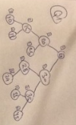

**Question 2.**

1. **Start from the BST you built. Delete 30**

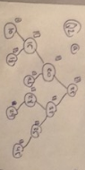

1. **Start from the BST you built. Delete 25**

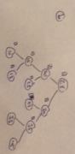

1. **Start from the BST you built. Delete 28**

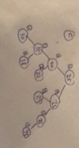

**Question 3.**

**(a) Start from the BST you built. Preorder traversal**

**(b) Start from the BST you built. Postorder traversal**

**(c) Start from the BST you built. Inorder traversal**

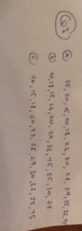

**Question 4. Write a recursive function to**

1. **count the nodes of a BST**

int getNodeCount(Node node) {

if (node == null) return 0;

return 1 + getNodeCount(node.left)+getNodeCount(node.right);

}

1. **count the leaves of a BST**

int getLeafCount(Node node) {

if (node == null) return 0;

if (node.left == null && node.right == null) return 1;

else return getLeafCount(node.left)+getLeafCount(node.right);

}

1. **create a mirror image of the BST**

Node mirror(Node node) {

if (node == null) return node;

Node left = mirror(node.left);

Node right = mirror(node.right);

node.left = right; node.right = left; return node;

}

# Lab10

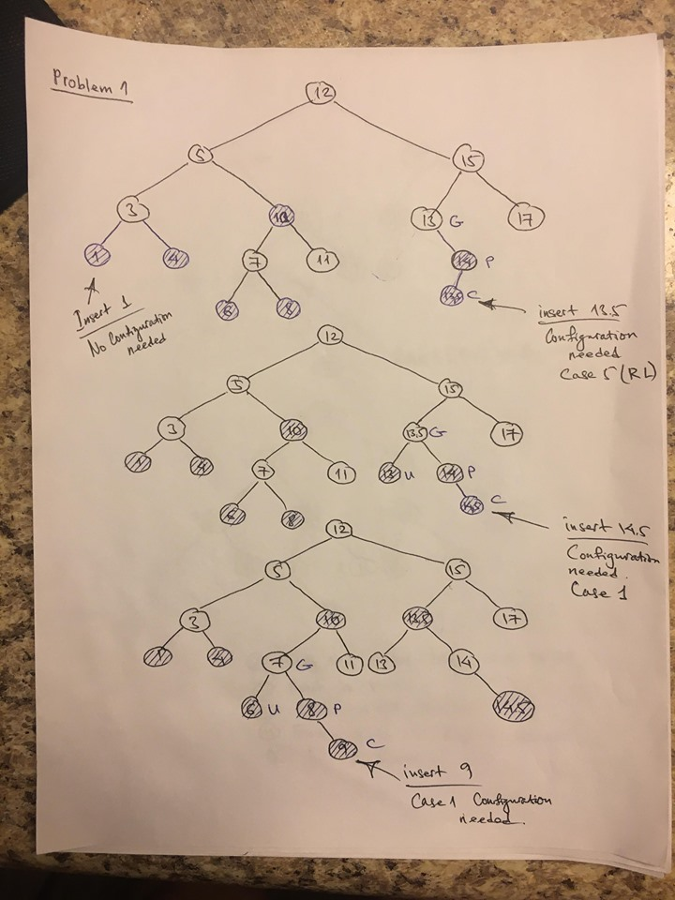

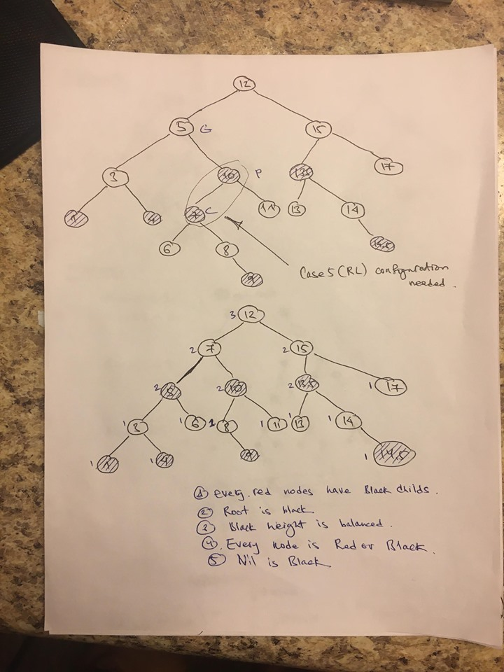

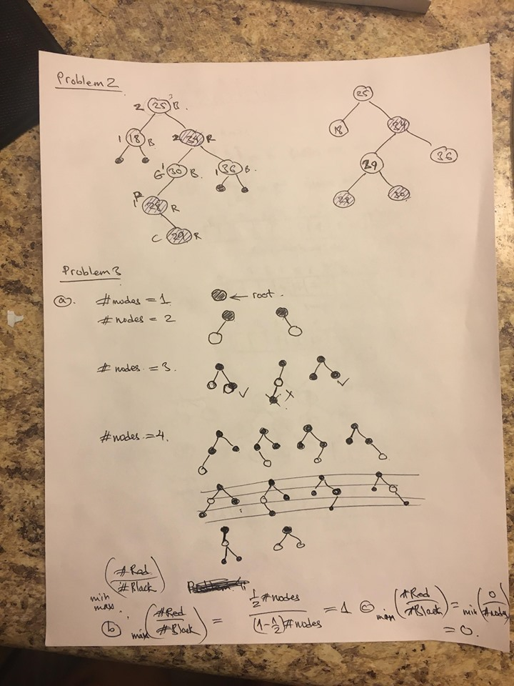

# Lab11

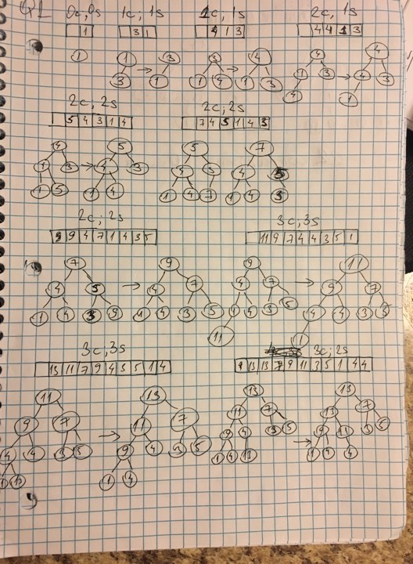

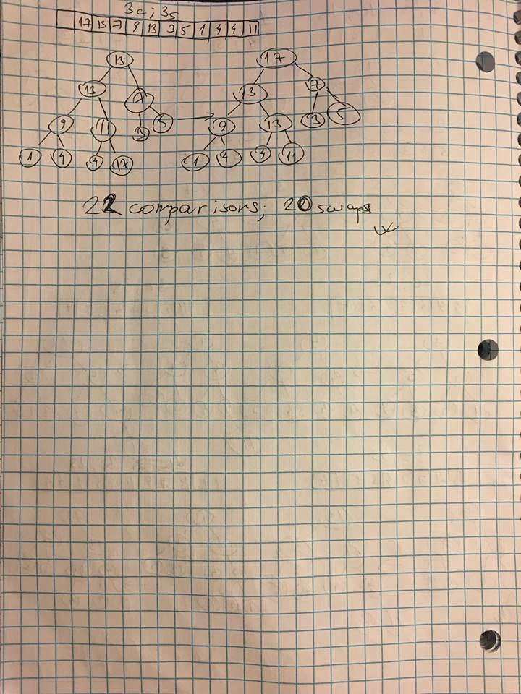

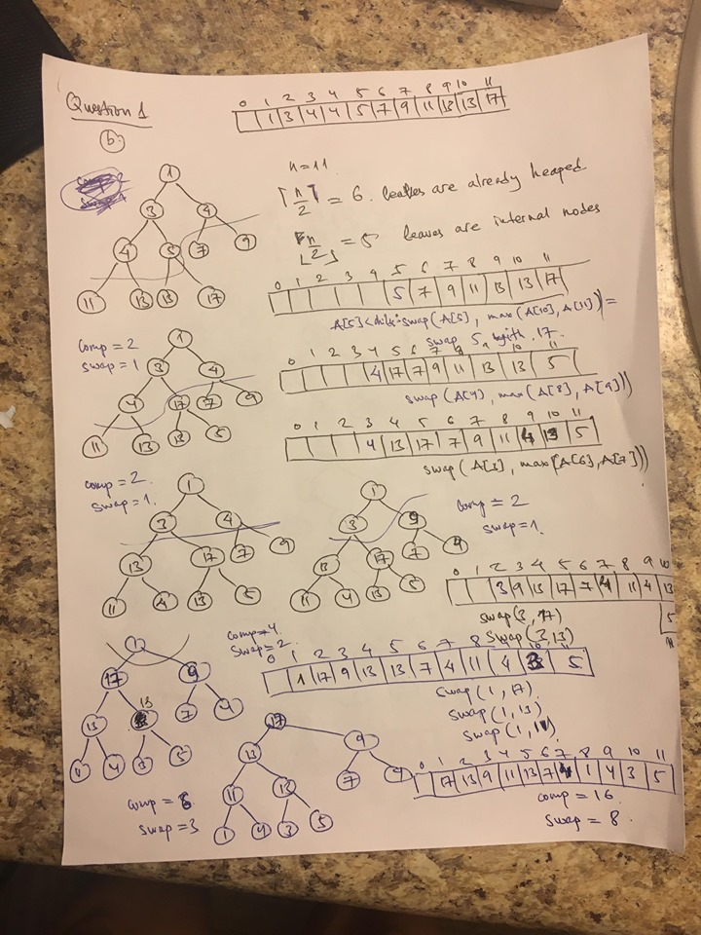

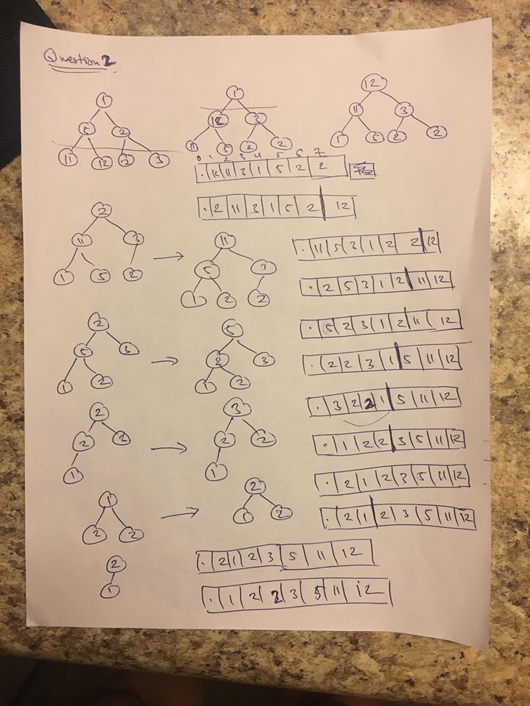

# Lab12

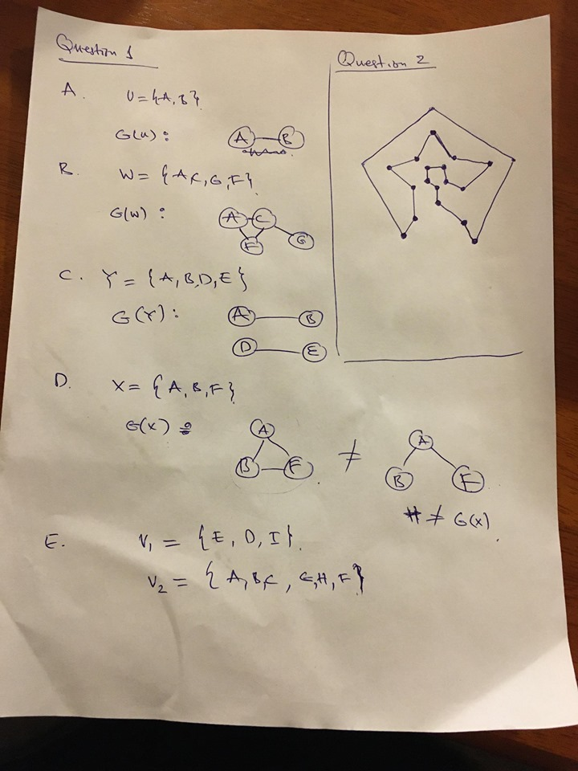

# Lab13

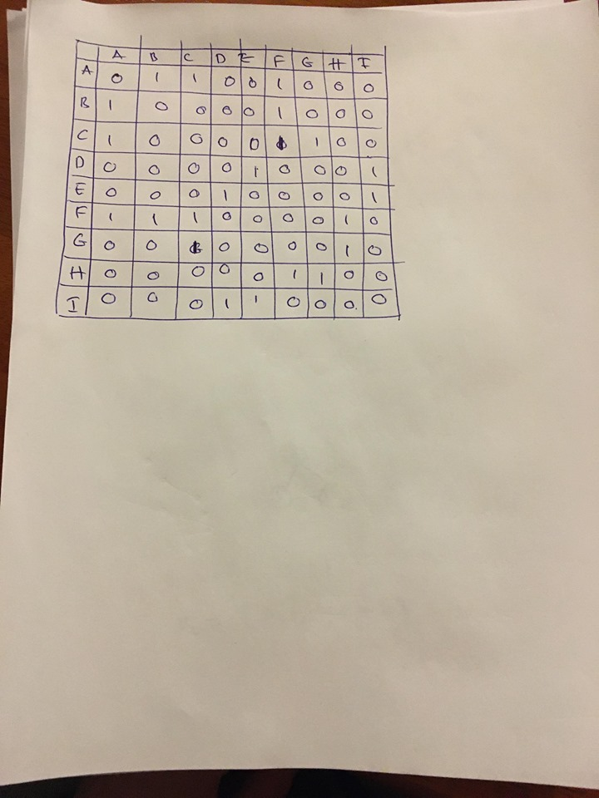

public List<List<Integer>> findComponentsByDFS(int[][] a) {

int length = graphs.length;

int[] visitedVertices = new int[length];

Stack<Integer> vertices = new Stack<>(); int v;

List<List<Integer>> components = new ArrayList<>();

for (int i = 0; i < visitedVertices.length; i++) {

if (visitedVertices[i] != 1) {

visitedVertices[i] = 1;

vertices.push(i);

List<Integer> component = new ArrayList<>();

component.add(i);

while (!vertices.isEmpty()) {

v = vertices.peek();

for (int j = 0; j < size; j++) {

if (graphs[v][j] == 1 && visitedVertices[j] != 1){

visitedVertices[j] = 1;

component.add(j);

vertices.push(j);

break;

}

}

if (j == size) {

vertices.pop();

}

}

components.add(component);

}

}

return components;

}

public static List<ArrayList<Integer>> findComponentsByBFS(int[][] a) {

int length = a[0].length;

boolean[] visited = new boolean[length];

for (int i = 0; i < length; i++) {

visited[i] = false;

Queue<Integer> queue = new LinkedList<Integer>();

List<ArrayList<Integer>> components = new ArrayList<ArrayList<Integer>>();

for (int x = 0; x < length; x++) {

if (!visited[x]) {

queue.add(x);

visited[x] = true;

ArrayList<Integer> component = new ArrayList<Integer>();

component.add(x);

while (!queue.isEmpty()) {

int t = queue.remove();

for (int i = 0; i < length; i++) {

if (a[t][i] == 1 && !visited[i]) {

visited[i] = true;

component.add(i);

queue.add(i);

}

}

}

components.add(component);

}

return components;

}